BIT 4107 – Mobile Application Development
ENHANCED PROFESSIONAL STUDENT LOGBOOK
Student Name: __Jaiyesimi Precious Eniola____________________________
Admission Number: ___BIT/2024/39050___________________________
School/Faculty: ____Computing and Informatics, Mount Kenya University__________________________
Programme: _______Information Technology _______________________
Academic Year: 4th______________________________
Semester: ____________First__________________
Lecturer: ______Mr Nyoro________________________

Week 1: Introduction to Mobile Application Development
Challenge faced:

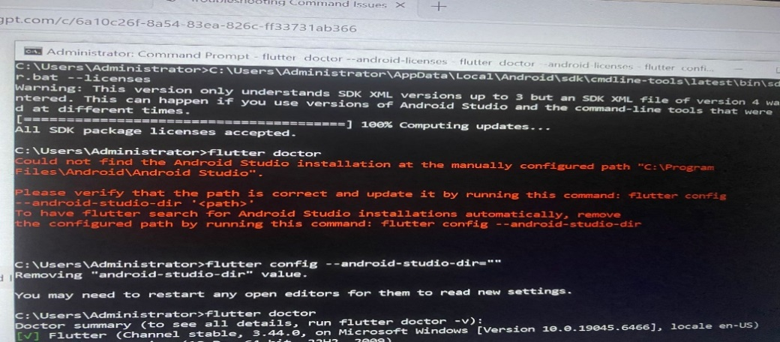
I found it difficult to set up the android studio tools and flutter was pointing at another Java path
Solution:
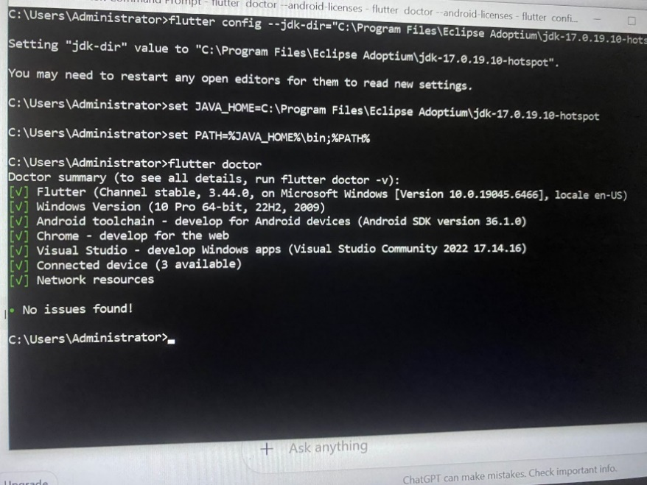
I eventually fixed it and set up all the environment
Then I Proceeded to create the App starting from Command prompt:
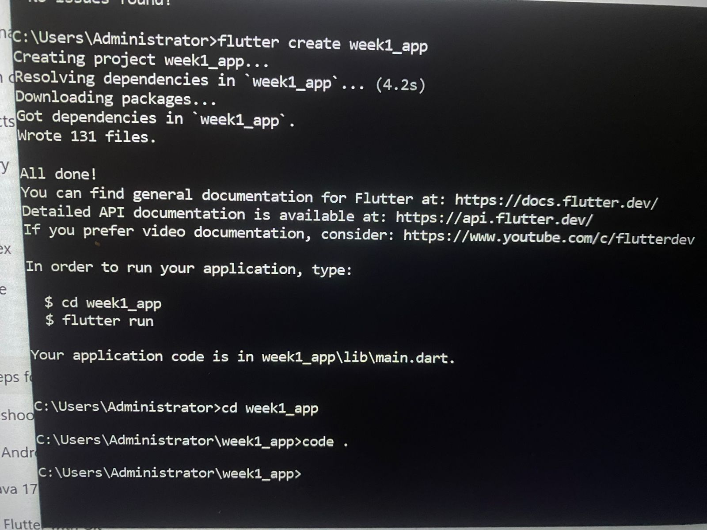

I was redirected to VS code and I ran flutter to start creating the app:
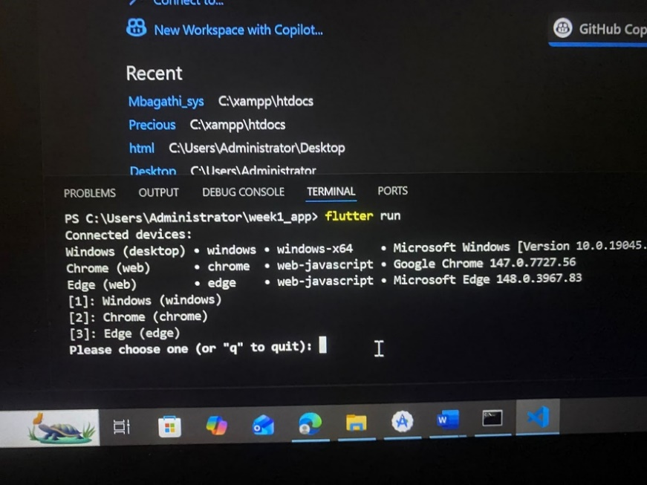
App created:
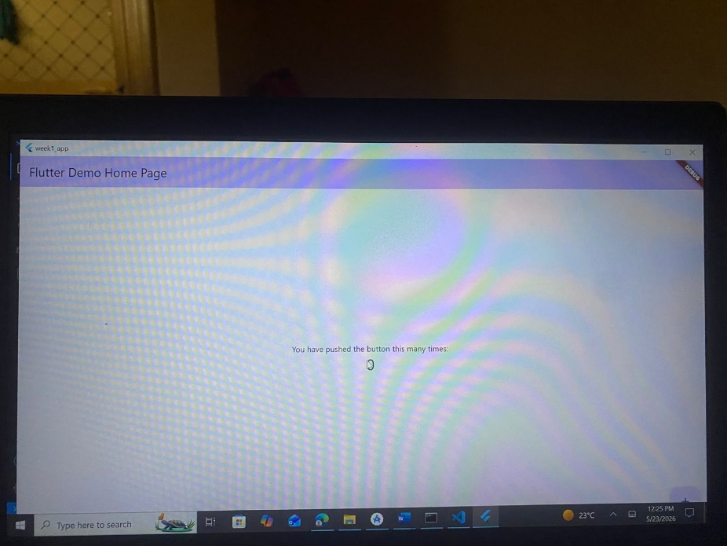

Then I Modified the app as instructed:
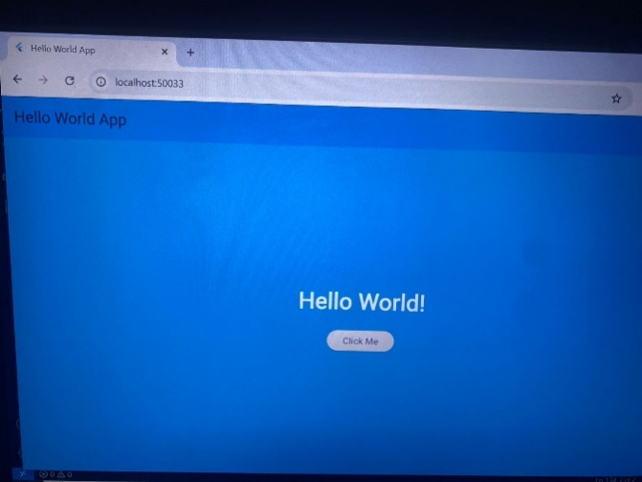

Tools/Software Used
- Flutter
- Java JDK 17
- Andriod studio
- Dart
- CMD

